Design Document _games  
Daniel Pokladek, Willoughby Axtell, Lenneth Dayaon

# What is our game?

Genre: Roguelite, fast paced

The emotions we want to evoke  
We want to create a Fast-paced game so we will be looking to evoke emotions of:   
**Tension** – We want to create tension by making the game fast paced allowing players to be fully immersed and concentrated through sections of the game.

**Hard Fun** – providing players the opportunity of challenge, mastery and feelings of accomplishments.   
We will focus on the attention to a goal which is for the player defeat bosses and maybe in the future, to different parts of the map. The constraints and strategy of the way players will surpass through the maps with varied enemy’s with distinct properties. Mastering our mechanics as they play through random generated maps. To help them feel accomplishments to how far they get.

**Frustration** – perma death is a mechanic in our game so the player will have to start from the very beginning when they die.

**Fiero** – From the constant dying and failing, it will be more appreciated when players succeed to beat boss fights and proceed through the maps. This should evoke fierro through the player defeating an obstacle, especially one that is annoying.

**Relief** – Players can have relief after defeating boss fights and have times in the game where they are able to just have some time to pause or slow down without affecting their player’s life.

# Fantasy themed

(mystical magic themes, good vs. evil)   
  
Theme classified by a mixture of sub genres:   
**Comic Fantasy:** humorous in tone   
**Contemporary fantasy**: set in the real world by involving magic or other supernatural elements.   
**Heroic fantasy:** concerned with the tales of heroes in imaginary lands  
**Low fantasy:** characterized by a few or non-intrusive supernatural elements, often in contrast to high fantasy.

<https://en.wikipedia.org/wiki/Fantasy>

# Mechanics

# Art style

* 2D at a 45-degree angle

Example:

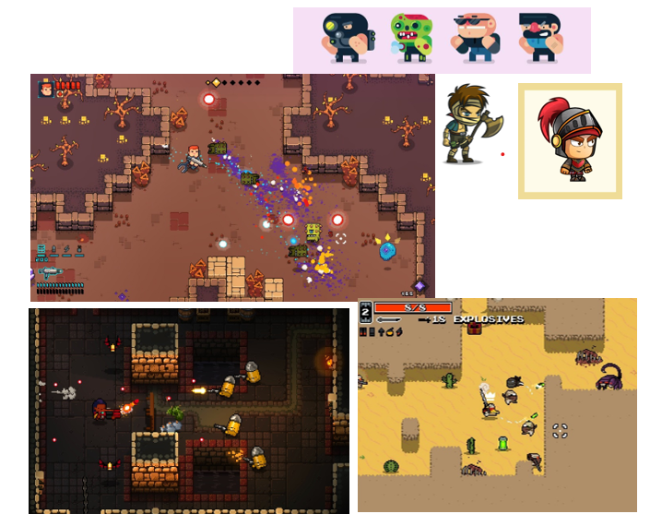

# WHAT ARE THE KEY DESIGN PROBLEMS YOU WILL FACE?

WHAT ARE THE KEY PROGRAMMING ISSUES YOU WILL HAVE WITH THIS GAME?